Lecture 15: Chapter 6: Methods
Announcements

Reading
- Chapter 6 - Methods

Today’s Goals
- Caution with Value Returning Method
- Midterm Review

Caution with Value Returning Methods

Recall - a return statement is required with a value-returning method.

Here is a method that will return an integer value

public static int sign (int number) {
if (number > 0)
return 1;
else if (number == 0)
return 0;
else if (number < 0)
return -1;
}

But the complier says there is an error: This method must return a result of type int
Why is that the case?
- To the complier, it appears possible that the method might not return a value
- This happens because its "appears" as if it is possible to not match any "if else" clause

- The method needs to be re-written to

public static int sign (int number) {
if (number > 0)
return 1;
else if (number == 0)
return 0;
else else if (number < 0) is removed
return -1; no more complier error!
}

- Even better, write the method using structured programming – one entry point, one exit point:

public static int sign (int number) {

int returnValue;
if (number > 0)
returnValue = 1;
else if (number == 0)
returnValue = 0;
else
returnValue = -1;

return returnValue;
}

Method Abstraction & Stepwise Refinement – Not Part of Lecture – Extra Information

Method Abstraction
- Using a method without knowledge of its implementation

- "Black box" mentality
  - You use it (by specifying method name and parameters) but
  - Don't know how it is implemented (the method body)

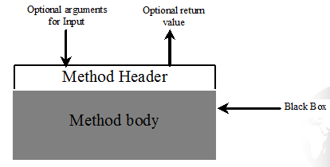

- Been doing this with all the pre-defined methods
  - Math.random
  - input.nextInt()
  - System.out.println()

- The details are hidden in the method (or encapsulated within the method)
  - This allows the code within method to change without affecting the user of that code
  - If a new version of Java changes the input.nextInt() method to be more efficient you would never know and your code using the input.nextInt() would not be affected
  - This is true as long as the parameter list does not change

- Encapsulation or information hiding are two terms we will discuss more when we get into objects

Top-Down Implementation
- Idea is to implement one method in the structure at a time from top to bottom
- Some components might be too simple - in this case combine
- Stubs
  - Incomplete versions of a method
  - Used to build framework/skeleton for the program
- For above example, we could build framework
  - See page 228 of book

Stepwise Refinement
- Also, called divide and conquer
- Strategy to design code
- Breaking the code down into subcomponents
- Benefits
  - Simpler program
  - Reusing methods
  - Easier development, debugging, and testing
  - Facilitates teamwork

Stepwise Refinement Example

Write a program that prompts the user for a month and year and then displays the calendar for the month.

Sample Output
Enter full year (e.g. 2017): 2012
Enter month as number between 1 and 12: 3

March 2012
-------------------------------
Sun Mon Tue Wed Thu Fri Sat
1 2 3
4 5 6 7 8 9 10
11 12 13 14 15 16 17
18 19 20 21 22 23 24
25 26 27 28 29 30

Applying Stepwise Refinement
- Easier to approach the problem by breaking it down into its components!
- Start at highest level
  - Specify top level components
  - Specify without details each level
- As move to next lower level, provide more detail
- Continue until problem is reduced to base components

- Example with structure charts

- 1st step - start at the highest level
  - Get some information from user
  - Print the calendar for the month

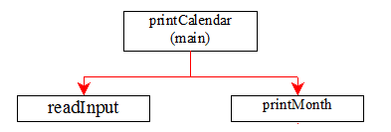

- 2nd step -break down printMonth
  - Print the title for the month
  - Print the days of the month

Not details yet - just general high level subcomponents!
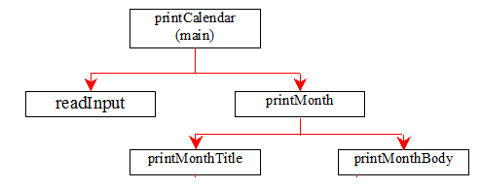

- 3rd step - work on printMonthTitle
This component will display the name of
the month, the dashed line, and days of week
Only refinement left is to convert the month
number into a month name
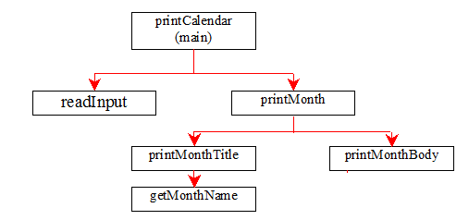

- 4th step - work on printMonthBody
Still working problem from a high level
1st figure out what day of week is day 1
for selected month
2nd determine how many days in month
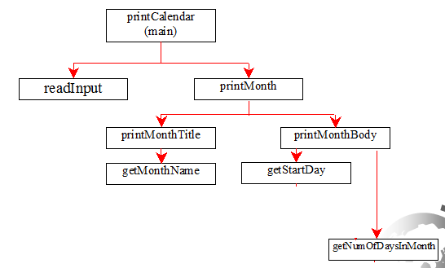
- 5th step - work on getStartDay

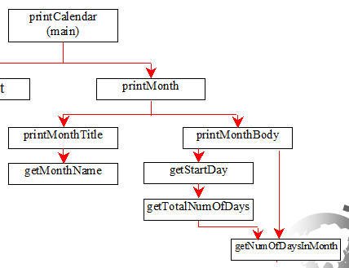

- 6th step - work on getNumOfDaysInMonth

